TOWNSHIP OF WINFIELD

BUILDING DEPARTMENT
Deck Requirements

A completed construction permit application, including: Construction Permit Application Folder
Building Subcode Technical Section Application for Certificate

Submit two (2) sets of plans that are clear and legible. To draw your own plans, you must be the owner and occupant of the property. If not, you will need drawings by a New Jersey Registered Architect. The homeowner’s signature must be on the plans that they prepare and Certification In Lieu of Oath in the Construction Permit Application Folder.

All multi-family type structure plans are required to be designed by a NJ Licensed Architect. The drawings submitted shall include the following information:
- Length, width and height above grade. Provide type of lumber (A.C.Q. treated lumber, cedar, or other naturally durable product)

- Provide footing locations: Distance from house or structure and between each other. Minimum footing size to be 14” wide and 36” below finished grade.

- Provide support column size and spacing: (4x4) for deck heights up to 6’ and (6x6) post for deck greater than 6’ above finished grade. Columns to be anchored to footing using a proper post saddle or equivalent type anchor. Column cannot be encased in concrete.

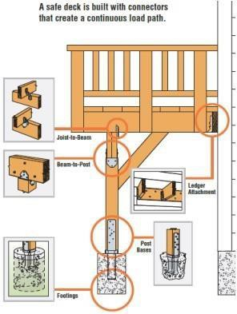

- Show size, length and direction of girder over column support post. Girder required to be top loaded on support columns not sandwiched between columns. If girder needs to be spliced together, splices are to occur over column/footings. Nail girder together with 3-16d galvanized nails 16” on center
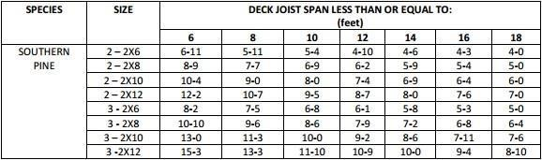

- Floor Joist: 2015 International Residential Code, New Jersey Edition, Section R507.5: Deck Joists – Maximum allowable spans for wood deck joists, as shown in Table R507.5, shall in accordance with Table R507.5. Deck joists shall be permitted to cantilever not greater than onefourth of the actual adjacent span.
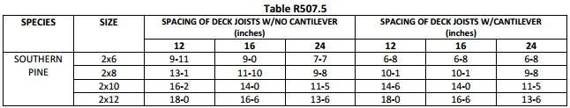

- Ledger: Board against house securely attached with ½” diameter galvanized lag bolts of sufficient length to bolt firmly into rim joist a minimum of 2 ¼”. Lag bolts shall be 16” on center in a staggered pattern. Provide two bolts, one above the other, at each end. Provide galvanized washers between heads of bolts and wood. Through bolting with a washer on the outside and a washer and nut on the inside of the building, with similar bolting pattern as lag bolt is also acceptable.

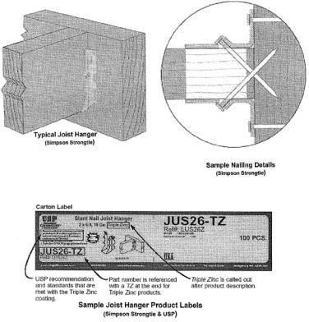

- Decking: Exterior wood and plastic composite deck boards shall be installed in accordance with manufacturer’s specification. 2 copies of manufacturer installation specs shall be provided with application for resurfacing of existing deck structures only.

- Flashing: Provide continuous corrosion-resistant flashing along ledge in such a manner as to prevent the passage of moisture into the wall, any untreated wood or wood siding. (Exception) Not required if against vinyl siding, metal siding or masonry. In this case provide shims as not to crush siding when bolts are tightened.

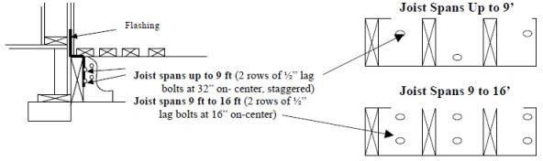

- Guards: Walking surfaces and open sides of stairs more than 30” above grade shall have guards not less than 36” measured vertically from the stair nosing and not less than 36” above a walking surface. Balusters or spindles shall be constructed so a 4” sphere cannot pass. (Exception: The triangular opening at the bottom rail of a guard and stair shall not allow the passage of a 6” sphere. Guards shall be constructed to withstand a 200 pound load in any direction along the top rail.

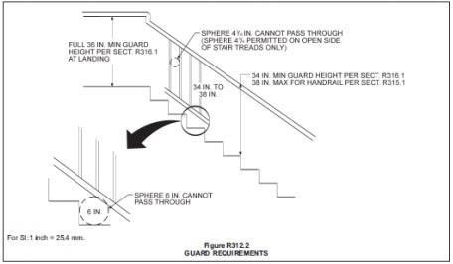

- Stairways: Minimum stairway width is 36”, maximum riser height is 8 ¼”, minimum tread is 9”. A nosing not less than ¾” but not more than 1 ¼” shall be provided when solid riser are used. Stairways more than 12’ above floor level or grade required a landing.
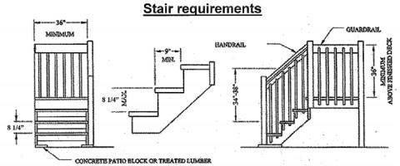

- Handrails: All stairways with four or more risers require continuous handrails. Handrails shall not be less than 30” or greater than 38” measured vertically from the stair nosing. Handrails shall be continuous the full length of the stairs. Handrails shall be returned or shall terminate to a wall or post. Grip sizes shall be in accordance with the 2015 International Residential Code, New Jersey Edition, Section R311.7.8.3. Type I or II.
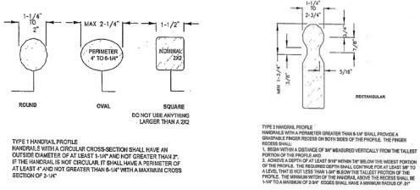

- Lateral Bracing: If the deck is far enough above ground to cause it to sway, diagonal bracing is to be installed between girder and posts.

- Connectors: All connectors, nails, screws, bolts and related hardware shall be hot-dipped zinc coated (galvanized), stainless steel, silicon bronze, copper or other corrosion resistant materials. When using hangers (TECO) all round holes must be filled using (TECO) nails.

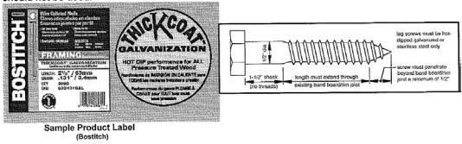

- Required inspections: Call (908) 709-7213 between the hours to 8:00 a.m. and 4:30 p.m. to schedule inspections.

Footing Inspection: before the placing of any concrete
Framing Inspection: prior to installing decking and after all footings have been poured, columns, girder and floor joist have been installed. Al flashing to be in place, all TECO slots nailed, ledger board lag bolted and all columns secured to footings girder/floor joist nailed to code.
Final Inspection: when all decking, guardrails, stairs and graspable handrails are installed and completed for issuance of a Certificate of Occupancy.

Failure to request required will result in a penalty being issued to the owner and/or contractor

VERY IMPORTANT!

You must leave your copy of the plans ON THE JOB SITE for all inspections. You do not have to be home for these inspections if you leave access to the area and leave the plans for the inspector. Please keep all pets locked up when you know the inspector will be at your home.

